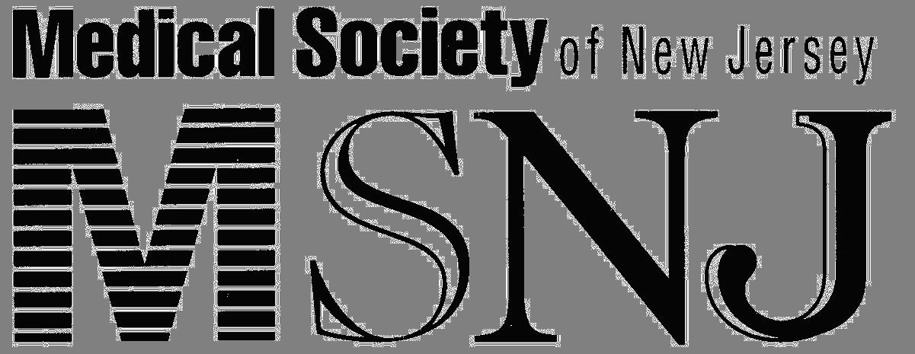

Date: July 30, 2026 Two Princess Road
Lawrenceville, NJ 08648-2303
From: The MWW Group Phone: 609-896-1766
Jon Hendl: P: 201-507-9500 Fax: 609-896-1368
MSNJ Web Site: www.msnj.org
John Shaffer: P: 609-896-1766, x-264

Statement Regarding Medical Liability Crisis and
Anticipation of Physician Work Slowdown

Following the January 19, 2003 meeting of the Medical Society of New Jersey Board of Trustees, President Robert S. Rigolosi, MD, announced this resolution that had been approved by the Board.

“The Medical Society of New Jersey strongly supports the efforts of New Jersey physicians to communicate their outrage with the failure of the Legislature to take meaningful action to resolve the medical liability insurance crisis. The Society will devote all of its resources to assist physicians, hospital medical staffs, and other physician organizations in exercising their rights. The Society will provide necessary legal services, distribute communications among the various grassroots efforts, coordinate public relations and rally public opinion.

Physicians throughout the State are planning to refuse to provide non-emergent and non-urgent care beginning on February 3, 2003. Physicians will continue to treat emergencies and provide necessary urgent and continuing care for those under active management during this time.

The Medical Society is also calling upon all physicians to march on Trenton on Tuesday, February 4, 2003 to demonstrate their resolve and the need for immediate action by the Legislature and the Governor, including controlling runaway jury verdicts by placing a cap of $250,000 on non-economic damages.”
# # #

Medical Society of New Jersey
Founded in 1766, the Medical Society of New Jersey is a voluntary association of 8,500 physicians statewide, whose mission is improving the health of New Jerseyans and acting on behalf of its members in legislative and regulatory matters.

